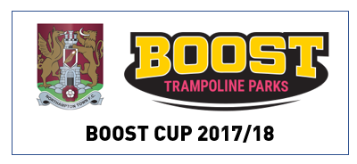
Dear Boost Cup team,
Thank you for entering your team in to the 17/18 Boost Cup Quarter Finals, please see below competition rules. By entering your team you agree to adhere to these rules.
- Please use your tickets to enter the Mick George Family Area and be seated no later than 1.50pm, we will then come and collect the children from their seats to flag wave around the pitch just ahead of kick off
- Final ticket requests are needed 4 weeks prior to the date attending along with a current team photo for the match programme
- All payments must be made to the ticket office no later than 2 weeks before the date attending
- 10 goals will count, if you have less than 10 players then some players can take another penalty until 10 have been taken
- Boost bibs must be worn at all times during the competition
- In the event of a draw after 10 goals, it will go to sudden death
- You are committing to a maximum of 4 games in the 17/18 season if you progress through the stages
- Prices are discounted to £16 for adults and £8 for U18's. There will be no further reductions on these prices for any reason
- Parents and other spectators must remain in their seats at all times. Only the main team Coach plus one other adult are permitted pitch side
- All players/Coaches must remain on the track and not enter the pitch until it is their turn to take the penalty
- We reserve the right to take photographs and video footage to use in the club’s promotional materials. Other parents and guardians are also given permission by way of these rules. If you do not wish your child to be photographed/video’d please excuse them from the competition
- The referee’s decision is final
- The club take no responsibility for any personal injury or loss of personal items during this competition
Many thanks and good luck.
Christine Clark
Ticket Office Manager

T: 01604 683777 | email: Christine.clark@ntfc.co.uk

